EECE 435L-Lab 8
Name: Jad Tannir
ID:202306271

Activity -1
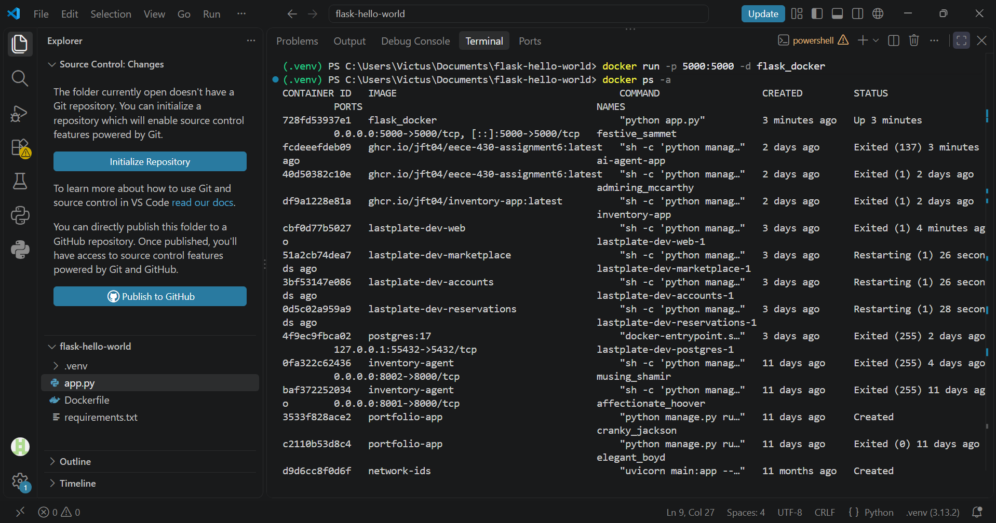
docker ps -a: list all the containers (running, stopped, restarting, created but not yet started) created on my docker desktop.
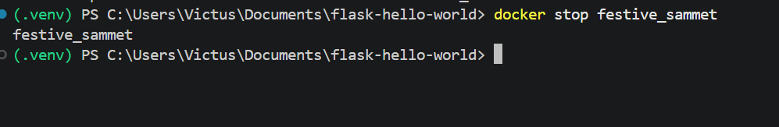
docker stop festive_sammet: stop a running container (“festive_sammet” in this case).

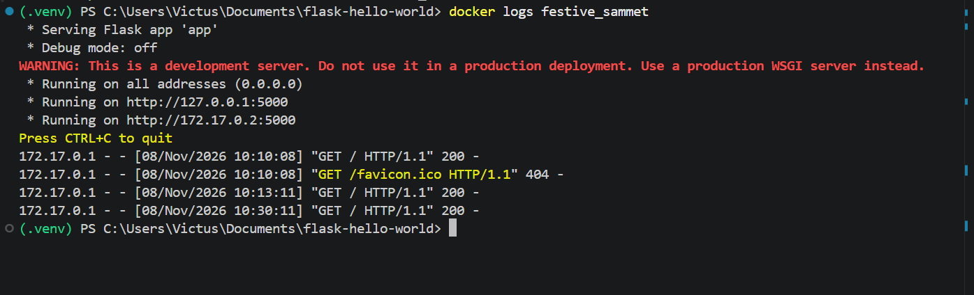
docker logs festive_sammet: display the logs (output) generated by the application (“hello world” flask app in this case) inside the container (“festive_sammet” in this case).

Activity -2


